

|  |
| --- |
| Assignment 1 |
| 08/09/18 00:50 |
| **Author:** Colin Barber - 27735731  **File name:** Assignment 1.vp  **Version** 1.0 |

|  |
| --- |
| Site Map |
|  |

|  |
| --- |
|  |

01. Site Map / Assignment 1 

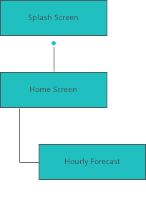

|  |
| --- |
| Screens |
|  |

|  |
| --- |
|  |

02. Screens / Assignment 1 

Splash Screen

|  |
| --- |
|  |

Interactions

|  |  |
| --- | --- |
| 1 | **on Click:** goes to 'Home Screen' 🡪 |

02. Screens / Assignment 1 

Home Screen

|  |
| --- |
|  |

Interactions

|  |  |
| --- | --- |
| 2 | **on Click:** goes to 'Hourly Forecast' with effect: slide left 🡪 |

02. Screens / Assignment 1 

Hourly Forecast

|  |
| --- |
|  |

Interactions

|  |  |
| --- | --- |
| 3 | **on Click:** goes to 'Home Screen' with effect: slide right 🡪 |

|  |
| --- |
| Templates |
|  |

|  |
| --- |
|  |

03. Templates / Assignment 1 

Template 1

|  |
| --- |
|  |

|  |
| --- |
| Scenarios |
|  |

|  |
| --- |
|  |

04. Scenarios / Assignment 1 

default

|  |
| --- |
|  |